(Approx. 815 words)

Musings of an Apple Tyro
By Lorrin R. Garson, Potomac Area Technology and Computer Society
November 2016 issue, PATACS Posts
www.patacs.org
newslettercolumnist (at) patacs.org

More Information About Time Machine
Time Machine is used for backup by many (most?) people using Apple computers. However, that application provides rather sparse information about what’s going on. Want more information? Open the Console, which is in either the Applications or Utilities folder, depending on the version of OS X. The right three columns will display processes that have been run. The Time Machine process is called “backupd”. Key “backupd” (no quotes) in the search box of Console, then start up Time Machine, noting the time in the Menu bar so you can view the processes for that specific instance of backupd. In Figure 1 are shown the processes associated with Time Machine for a specific manual backup starting at 1:57:27 pm. It takes some experience to comprehend the displayed information. However, with experience you will gain the ability to know when something is amiss even if you don’t understand all information provided—and that is valuable.

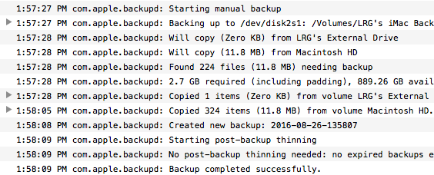
Figure 1

Seagate 10 TB Hard Drive
If you need a large and fast hard disk drive, Seagate’s Barracuda Pro 10 TB might fit the bill. PCWorld reports that this 3.5-inch, 7,200 rpm drive is miserly on power consumption and reads and writes data at 243 MBps and 229 MBps, respectively. The drive is priced at $579.98.
See http://bit.ly/2ctR6Il for more information.

Internet of Things and Security
As the Internet of Things (IoT) expands there is increasing awareness and discussion about the security of such devices. In fact, there is a general sense that IoT devices are inherently insecure. Our son had me load an app on my iPhone that would open and close the garage door to his home so we could enter his house while he was away. Of course he gave me the password to make this app work. Is the password encrypted as it’s sent over a cell phone radio signal or via the Internet? I don’t know. It’s been tempting to open and close his garage door several times at 2:00 am from our home in Vienna, but I’ve resisted that evil impulse.

According to an article in The Economist (June 11, 2016, pp. 65-66), IoT is rather slow to catch on in the U.S. Surprisingly, it seems that only 6% of homes here have installed an IoT device and by 2021 that number will have increased to only ~17%.
For some insight on IoT see http://bit.ly/2caL7oC and http://bit.ly/2cLAYUX and http://bit.ly/2cqvaRy.

People Holding on to iPhones Longer
Last year people traded in their iPhones every two years. By 2018 that’s expected to increase to three years. The following chart is from http://read.bi/2cAJpNY.

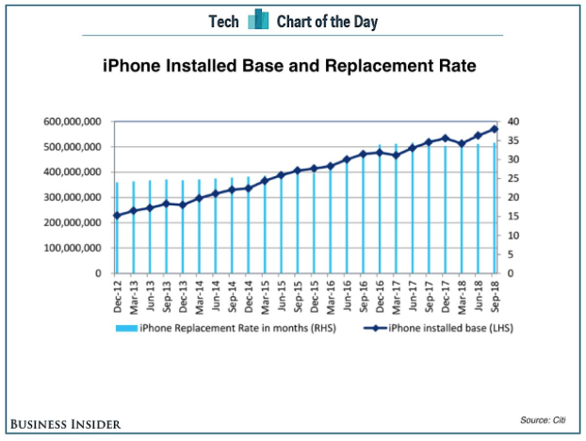

Apple’s New File System
Next year, or perhaps sooner, we can expect a new proprietary file system for Apple computers. It’s called APFS (Apple File System) and will replace the current HFS+ file system. HFS+ was introduced by Apple in January 1998 as a replacement for HFS (Hierarchical File System), which came along in September 1985. APFS will be used by macOS, tvOS, iOS and watchOS. It is designed for SSD and flash storage. It is crash-protected and HFS+/HFS compatible. Apple will provide an in-place HFS+ to APFS converter so that HFS+ devices will not have to be reformatted. OS X Yosemite and earlier versions of the operating system will not be able to use APFS. APFS will be available, and be the default file system, in 2017. Presumably MS-DOS (FAT) formatted disks will still be readable by both Apple and Windows machines.
See http://tidbits.com/article/16584, http://apple.co/2cgZGug and http://apple.co/2ctW4og.
See http://apple.co/2cgZGug for a 36-min video.

Snoop-proofing Your Mac
See http://bit.ly/2cAMg9t for interesting guidance on securing your Apple computer. If you following all the suggestions your machine will be quite secure but probably significantly crippled. To quote from this article, “…but be very careful once you make
changes outside System Preferences. Seriously, you have been warned”.

Beware of MacKeeper
I think the best that can be said of MacKeeper (https://mackeeper.com/) is that it’s very controversial. Before installing this software search the Web for reviews of this product. See http://bit.ly/2czFXpX for Wikipedia’s description of the software.
See http://apple.co/2cpWpXe and http://bit.ly/2d0QrNA for negative reviews.
See http://bit.ly/2cqzX5o for information on uninstalling MacKeeper and other products.

Apple’s New Corporate Headquarters
Apple is building a new facility in Cupertino, California on One Infinite Loop (where else?). Construction began in late 2013 and is expected to be completed late this year or early 2017. The facility will have 2.8 million ft² of office space and house about 12,000 to 13,000 employees. There are 3.7 miles of curved glass and 700,000 ft² of solar panels. The site is on 176 acres and has 7,000 trees and 15 acres of grassland. Cost? $5 billion.
See http://bit.ly/2cpZBli for a 4-minute video. Also see http://bit.ly/2cM1LgV and http://for.tn/2cqAC6V.

